**4th Annual MA Jobs and Workforce Summit: Accelerating Economic Growth**

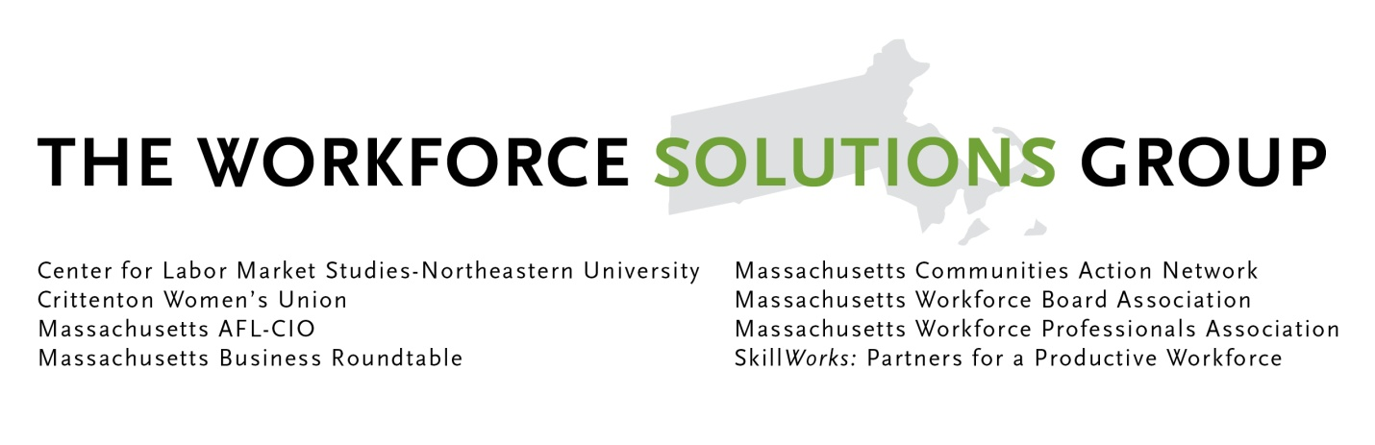

**8:30 AM – 9:00 AM REGISTRATION AND NETWORKING BREAKFAST**

**9:00 AM - 9:15 AM WELCOME AND FRAMING THE ISSUES**

**Chris Kealey, Deputy Director, MA Business Roundtable**

**President Steve Tolman, MA AFL-CIO**

**9:15 AM – 10:30 AM FEATURED MORNING SPEAKERS**

**Introduced by Stan Usovicz, Regional Director, Verizon MA**

**Steve Vinter, Site Director, Google Boston**

**Robert A. DeLeo, Speaker of the House, Massachusetts State House of Representatives**

**10:30 AM-10:45 AM NETWORKING BREAK**

**10:45 AM – 12:00 AM TOWN MEETING**

**TOPIC: How To Best Stimulate Job Growth and Economic Development? What is the role of government and the private sector?**

**Moderator: Shirley Leung, Boston Globe**

**Panelists:** **Ranch Kimball, COO, Babson College**

**Marty Jones, President and CEO, MassDevelopment**

**12:00 PM – 1:15 PM LUNCH PROGRAM**

WSG 2013 Workforce Champion Awards

**1:15 PM – 2:00 PM AFTERNOON FEATURED SPEAKER**

**Introduced by JD Chesloff, Executive Director, MA Business Roundtable**

**Marcy Reed, President, National Grid, MA**

**2:00 PM -2:15 PM NETWORKING BREAK**

**2:15 PM – 3:15 PM BREAK OUT SESSIONS - Best Practices and New Ideas**

**Tricia, we need to list all the speakers here for break out sessions**

* Assessing Career Pathways
* Working with Teens on Job Readiness and Success
* Preparing for Workforce Changes in Health Care
* Jobs in the Gaming Industry in Massachusetts
* Job Quality and Mobility Strategies - Aspen Institute

**3:30 PM – 4:00 PM FINAL REMARKS AND WRAP-UP**